**All Beach Tour Price USD$295**

**All Beach Tour Places**

# Y DOC LET BEACH EXCURSION - NHA TRANGA DAY DOC LET BEACH EXCURSION - NHAET BEACH EXCURSION - NHA TRANG A DAY DOCA A Day Doc Let Beach Excursion - Nha Trang

PROGRAM DETAILS

Start today’s journey with a hotel pick-up at 8:30 AM and enjoy a beautiful one hour drive through small mountains and idyllic seaside scenery before arriving to Doc Let. En route, stop at Ninh Thuy to visit a small and charming fishing village. Visiting this traditional village is a good way to discover local daily life and work activities. After, head to the beach to relax, spending time sunbathing and swimming. Upon return to Nha Trang, visit picturesque Ninh Diem salt fields. Salt water is directed into fields and left for days to evaporate. The white mineral is then removed and left to dry before harvesting. Continue back to Nha Trang after a relaxing day on the north coast of Nha Trang.

(Lunch is not included; guests may want to choose to have hotel prepare a box lunch for beach picnic or have lunch at the White Sand Doclet Resort and Spa).

Recommendations: the best time to attend this tour is from January to September in order to avoid the raining season.

PRICING: Please contact us for rates

Our services include:

* English speaking local guide (for other languages supplements apply)
* Tours and transfers as mentioned by private air conditioned vehicle

Our services do not include:

* Other meals than mentioned
* Other services than mentioned
* International and domestic Flights
* Towel and chair

# BEACH EXCURSION - NHA TRANG LET BEACH EXCURSION - NHA TRANGA DAY DOC LET BEACH EXCURSION - NH South Vietnam Family Adventure

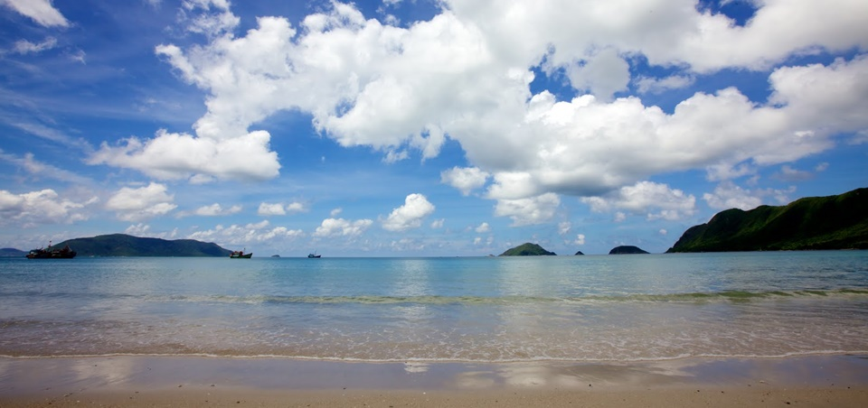GA DAY DOC LET BEACH EXCURSION - NHA TRANGA DAY DOC LET BEACH EXCURSION - NHA TRANG

IMPORTANT NOTES:

* We strongly recommend the purchase of travel insurance (covering emergency medical evacuation) for trips to Vietnam.
* Prices are valid 30 days from date of offer. Past this date price and conditions may be readjusted.
* The cost of air tickets is subject to change without prior notice by the airlines.
* Reservations during peak times (Christmas, New Year, Vietnamese Lunar New Year, National Holidays) may be subject to supplementary charges.
* Rooms at hotels are available only from 1400 on arrival day till 1200 on departure date. A supplement will be added if early check-in or late check-out is desired.
* Please note that all the above services & tours have yet to be booked, they are proposed for your information only and we will not make any reservations before we receive your confirmation to do so.
* If one or some proposed service(s) is (are) not available at the moment of booking, we will try to find other possibilities/options or other similar service(s) in order to avoid changes to the program.

# *One Day, Nha Trang ''Insider'' Tour - Nha Trang*

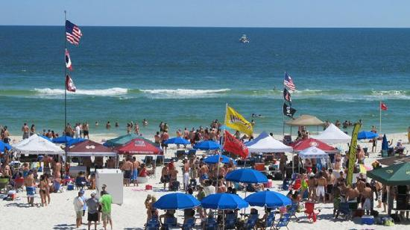

PROGRAM DETAILS

Depart from the hotel and start the day with a visit to the spectacular Po Nagar Temple Tower, dating from the 8th Century.  This unique architecture is a symbol of Hindu Champa culture and remains a place of worship for all religions.

Wander through a small local alleyway to a boat builder’s house where guests will board a riverboat. Float past lush countryside, a boatyard that makes fishing boats and by a photogenic fleet at a fishing village.  The time on the boat, floating gently down the river, is truly a highlight of the journey. Disembark and visit a family who make traditional clay stoves and another family that weaves rush mats for a living. Visit a colorful local market and a local school (closed on Sunday and public holidays).

Head to lunch, stopping en route amongst the rice fields to watch and photograph the farmers and buffaloes at work (season dependent). Enjoy lunch at a fabulous restaurant set in an “ancient house” on the banks of a tranquil and spectacular lotus pond.  After lunch, drive back to the hotel. (L)

This tour offers fascinating insight into the "real lives" of everyday people who are the backbone of Vietnam.

